SIMATS ENGINEERING
ASSESSMENT TOOL 2

COURSE NAME: Database Management Systems
COURSE CODE: CSA05

COURSE OUTCOME COVERED

CO1: Analyse DBMS architecture, different data models, schema types, and design ER/EER diagrams, relational schemas for case-based scenarios by identifying entities and relationships. (BL1, BL2)

Activity Tool : Concept Mapping (Medium)
Assessment Tool Weightage: 20%

QUESTIONS
Q.No | Question | Bloom's Level
1 | Construct a concept map linking the following terms: DBMS, Schema, Instance, Data Model, ER Diagram, Entity, Attribute, Relationship. | BL2 –  Understand
2 | Create a concept map for the three-level ANSI/SPARC architecture showing data independence at each level. | BL2 –  Understand
3 | Map the relationship between file-based systems and database systems, highlighting the problems solved by DBMS. | BL2 –  Understand
4 | Design a concept map for ER diagram components:  entity, weak entity, attribute types, relationship types, and participation constraints. | BL2 –  Understand
5 | Construct a concept map comparing Hierarchical, Network, and Relational data models with their key properties. | BL2 –  Understand
6 | Develop a concept map for the EER model showing how it extends the basic ER model with generalization, specialization, and aggregation. | BL2 –  Understand
7 | Create a visual concept map for the DBMS software architecture, illustrating the flow from user request to data retrieval. | BL2 –  Understand
8 | Map the data models discussed in CO1 to real-world applications and explain the suitability of each model. | BL2 –  Understand
9 | Construct a concept map for schemas and instances, showing how they relate to physical and logical data independence. | BL2 –  Understand
10 | Design a concept map for the roles and responsibilities in a DBMS environment: DBA, End User, Application Developer. | BL1 –  Remember

Code of Conduct:

I ____M.sharmila(192572139)________________ (Name / Reg No) certify that this submission is my original work and that I have adhered to the guidelines specified for this assessment.
I understand that any violation of academic integrity rules will result in disciplinary action.

Signature of the student:

RUBRICS FOR CALCULATION:

Criteria | Weighta ge | Level 4  (Exemplary) | Level 3  (Proficient  ) | Level 2  (Developin  g) | Level 1  (Beginnin  g)
Concept  Identificati on | 25% | Identifies all key concepts from literature accurately and comprehensi  vely | Identifies most key concepts with minor omissions | Identifies limited concepts; some are irrelevant or missing | Fails to identify essential concepts
Linkages | 25% | Establishes clear, meaningful, and accurate relationships between concepts | Shows  correct relationshi ps with minor gaps | Relationshi ps are weak, unclear, or partially incorrect | No meaningfu  l  relationshi ps establishe d
Organizati on | 20% | Concepts are wellstructured hierarchically with logical flow and grouping | Mostly organized with minor structural issues | Some  organizatio n but lacks clear hierarchy | No logical organizati on or structure
Integratio n of Literature | 20% | Integrates multiple studies effectively to show connections and comparisons | Shows some  integratio n of literature | Limited integration ; mostly isolated concepts | No integratio n of literature evidence
Clarity | 10% | Concept map  is clear, neat, visually structured, and easy to interpret | Generally clear with minor readability issues | Clarity is reduced;  difficult to interpret in parts | Poorly presented and hard to  understan  d

1.Construct a Concept Map Linking the Following Terms: DBMS, Schema, Instance, Data Model, ER Diagram, Entity, Attribute, Relationship.
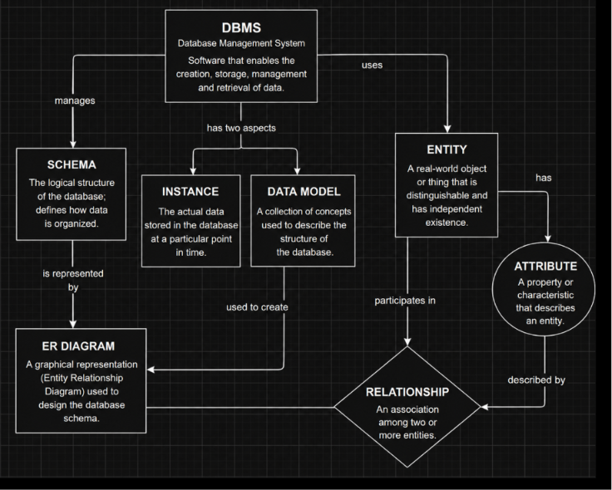
Diagram 1.1

Introduction
A Database Management System (DBMS) is software that enables users to create, store, retrieve, update, and manage databases efficiently. It provides an interface between users and data while ensuring security, consistency, and integrity. Before creating a database, a proper design is required. This design is achieved using concepts such as Data Model, ER Diagram, Entity, Attribute, Relationship, Schema, and Instance. These concepts are interconnected and together form the foundation of database systems.
1. DBMS (Database Management System)
A DBMS is software used to create and manage databases.
Functions of DBMS
- Stores and organizes data.
- Retrieves data efficiently.
- Updates and deletes records.
- Provides security and backup.
- Reduces data redundancy.
- Maintains data integrity.
- Supports multiple users.
Examples
- MySQL
- Oracle
- SQL Server
- PostgreSQL
Connection to Concept Map:
The DBMS is the central component that manages the entire database. It uses a Data Model, stores the Schema, and maintains the current Instance of data.
2. Data Model
A Data Model defines how data is structured, stored, and related within a database.
Types of Data Models
- Hierarchical Model
- Network Model
- Relational Model
- ER Model
- Object-Oriented Model
Among these, the Entity-Relationship (ER) Model is widely used during database design. Connection to Concept Map:
The Data Model provides the structure for designing databases and is represented through an ER Diagram.
- ER Diagram (Entity Relationship Diagram)
An ER Diagram is a graphical representation of the database structure. It is prepared before implementing the database.
Components
  - Entity
  - Attribute
  - Relationship
Advantages
  - Easy to understand.
  - Simplifies database design.
  - Identifies relationships between data.
  - Reduces design errors. Connection to Concept Map:
The ER Diagram is created from the Data Model and contains Entities, Attributes, and Relationships.
- Entity
An Entity is a real-world object or thing about which information is stored.
Examples
  - Student
  - Employee
  - Book
  - Course
  - Department
Example
Entity: Student
Information stored:
  - Roll Number
  - Name
  - Age
  - Department
Connection to Concept Map:
Entities represent the major objects in the ER Diagram.
- Attribute
An Attribute describes the characteristics or properties of an entity.
Example
Entity: Student Attributes:
  - Student_ID
  - Name
  - Age
  - Department
Types of Attributes
  - Simple Attribute
  - Composite Attribute
  - Single-Valued Attribute
  - Multi-Valued Attribute
  - Derived Attribute
Connection to Concept Map:
Attributes provide detailed information about each entity.
- Relationship
A Relationship represents the association between two or more entities.
Examples
- Student enrolls in Course.
- Employee works in Department.
- Customer places Order.
Types
- One-to-One (1:1)
- One-to-Many (1:M)
- Many-to-Many (M:N) Connection to Concept Map:
Relationships connect entities and define how they interact with each other.
7. Schema
A Schema is the logical blueprint of the database.
It defines:
- Tables
- Columns
- Data Types
- Primary Keys
- Foreign Keys • Constraints
- Relationships
Example
Student Table
Student_ID | Name | Department | Age
Course Table
| Course_ID | Course_Name |
The structure of these tables forms the database schema.
Connection to Concept Map:
The ER Diagram is converted into a Schema before implementation in the DBMS.
8. Instance
An Instance is the actual data stored in the database at a specific point in time. Example
Student ID | Name | Department | Age
101 | Rahul | CSE | 20
102 | Priya | AI | 19
103 | Arun | ECE | 21
The schema remains the same, but the instance changes whenever records are added, updated, or deleted.
Real-Time Example
Consider a College Database.
- DBMS: MySQL
- Data Model: Relational Model
- ER Diagram: Student, Course, Faculty
- Entity: Student, Course
- Attribute: Student_ID, Name, Department
- Relationship: Student enrolls in Course
- Schema: Student, Course, Enrollment tables
- Instance: Current student records stored in the tables
Conclusion
The DBMS is the core software that manages databases efficiently. It uses a Data Model to organize information and represents the design using an ER Diagram, which consists of Entities, Attributes, and Relationships. The ER Diagram is transformed into a Schema, which acts as the blueprint of the database. The actual data stored according to the schema is called an Instance. Thus, all these concepts are interrelated and together help in designing, implementing, and maintaining an efficient database system.

2. Create a Concept Map for the Three-Level ANSI/SPARC Architecture Showing Data Independence at Each Level.
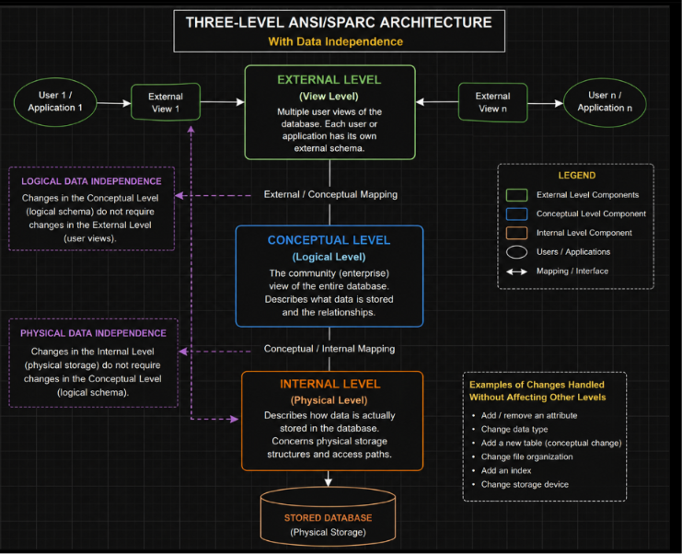
Diagram 2.1 concept coconcept mapcconcpet

Introduction
The ANSI/SPARC Three-Level Architecture is a standard database architecture introduced to separate user applications from the physical storage of data. It divides the database into three different levels: External Level, Conceptual Level, and Internal Level. This architecture provides Data Independence, allowing changes at one level without affecting the other levels.
The main objective of the ANSI/SPARC architecture is to improve flexibility, security, and ease of database maintenance.

- External Level (View Level)
The External Level is the highest level of the database architecture. It represents how different users view the database.
Features
  - Contains multiple user views.
  - Each user sees only the required data.
  - Provides security by hiding unnecessary information.
  - Different users can have different views of the same database.
Example
  - Student View
  - Faculty View
  - Administrator View
Each user accesses only the information needed for their work.
Connection to Concept Map:
The External Level communicates with the Conceptual Level and provides customized views to users.

- Conceptual Level (Logical Level)
The Conceptual Level describes the complete logical structure of the database. It defines:
  - Entities
  - Attributes
  - Relationships
  - Constraints
  - Data Types
It does not describe how data is physically stored.
Features
  - Represents the entire database.
  - Independent of physical storage.
  - Shared by all users.
Example
A college database may contain:
- Student
- Faculty
- Course
- Department
along with their relationships.
Connection to Concept Map:
The Conceptual Level acts as a bridge between the External Level and the Internal Level.

3. Internal Level (Physical Level)
The Internal Level is the lowest level of the database architecture.
It describes how data is physically stored in the computer. It includes:
- Files
- Storage blocks
- Indexes
- Access methods
- Memory allocation
Features
- Focuses on storage efficiency.
- Improves database performance.
- Hidden from end users.
Connection to Concept Map:
The Internal Level stores the actual database using physical storage techniques.

Data Independence
One of the major advantages of the ANSI/SPARC architecture is Data Independence.
It means changes at one level do not affect the higher levels.
There are two types of data independence.

- Physical Data Independence
Physical Data Independence means that changes made at the Internal Level do not affect the Conceptual Level or External Level.
Examples
  - Changing file organization.
  - Adding indexes.
  - Modifying storage devices.
  - Compressing database files.
The users and application programs continue to work without modification.
Advantages
  - Better performance.
  - Easier maintenance.
  - No changes required in application programs.

- Logical Data Independence
Logical Data Independence means that changes made at the Conceptual Level do not affect the External Level.
Examples
  - Adding a new attribute.
  - Adding a new table.
  - Modifying relationships.
  - Splitting a table into two tables.
The user views remain unchanged.
Advantages
  - Easy database modification.
  - Existing application programs continue to work.
  - Supports database growth.

Relationship Between the Three Levels
The three levels are connected as follows:
  - The External Level provides different views of the database to different users.
  - These views are mapped to the Conceptual Level, which contains the complete logical structure of the database.
  - The Conceptual Level is mapped to the Internal Level, where the data is physically stored.
  - Changes in physical storage are hidden by Physical Data Independence.
  - Changes in the logical structure are hidden by Logical Data Independence.

Real-Time Example
Consider a College Management System.
External Level
  - Student can view marks and attendance.
  - Faculty can update marks.
  - Principal can access all records.
Conceptual Level The database contains:
  - Student
  - Faculty
  - Course
  - Department
  - Examination with relationships among them. Internal Level
The data is stored in:
  - Hard disk
  - Data files
  - Indexes
  - Storage blocks
If the storage method changes (for example, adding indexes), users are not affected because of Physical Data Independence.
If a new attribute like Email ID is added to the Student table, existing user views remain unaffected due to Logical Data Independence.

Advantages of ANSI/SPARC Architecture • Provides Data Independence.
  - Improves database security.
  - Supports multiple user views.
  - Simplifies database maintenance.
  - Reduces application program changes.
  - Enhances flexibility and scalability.
  - Improves overall database performance.
Summary Table
Level | Purpose |  | Example
External Level | User-specific views of the database |  | Student View, Faculty View
Conceptual Level | Complete logical structure of the database |  | Tables, Relationships, Constraints
Internal Level | Physical storage of data Files, Indexes, Storage Blocks
Type of Data Independence |  | Meaning
Physical Data Independence |  | Changes in physical storage do not affect the conceptual or external levels.
Logical Data Independence | Changes in the logical structure do not affect user views.

Conclusion
The ANSI/SPARC Three-Level Architecture separates the database into External,
Conceptual, and Internal Levels, making database systems more flexible and efficient.
The External Level provides user-specific views, the Conceptual Level defines the logical structure of the database, and the Internal Level manages physical storage. The architecture achieves Logical Data Independence and Physical Data Independence, allowing changes at one level without affecting the others. This improves security, simplifies maintenance, and enhances the overall performance of database systems.

3.Map the Relationship Between File-Based Systems and Database Systems, Highlighting the Problems Solved by DBMS.
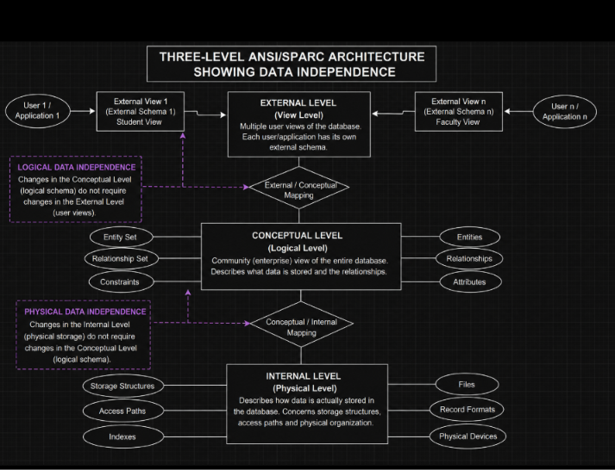
Diagram 3.1

Introduction
Before the development of Database Management Systems (DBMS), organizations stored data using file-based systems. In this approach, each application maintained its own separate files, leading to duplication of data and difficulty in managing information. To overcome these limitations, DBMS was introduced. A DBMS provides centralized storage, efficient data management, security, integrity, and easy access to information.

1. File-Based System
A File-Based System stores data in separate files maintained by individual applications.
Characteristics
- Data stored in different files.
- No centralized management.
- High data redundancy.
- Difficult to share data.
- Limited security.
Advantages
- Simple to develop.
- Suitable for small applications.
- Low initial cost.
Disadvantages
- Data redundancy.
- Data inconsistency.
- Data isolation.
- Difficult data access.
- Weak security.
- No proper backup and recovery.

2. Database Management System (DBMS)
A DBMS is software used to create, store, organize, retrieve, and manage data in a centralized database.
Characteristics
- Centralized database.
- Reduced redundancy.
- Improved security.
- Data sharing.
- Backup and recovery.
- Multi-user support.
Examples
- MySQL
- Oracle
- SQL Server
- PostgreSQL

Problems in File-Based System and Their Solutions in DBMS
Problem in File System | Solution Provided by DBMS
Data Redundancy | Reduces duplicate data using centralized storage.
Data Inconsistency | Maintains consistent and accurate data.
Data Isolation | Integrates all data into one database.
Difficult Data Access | Uses SQL for easy retrieval of data.
Security Issues | Provides authentication and access control.
Backup Problems | Supports automatic backup and recovery.
Concurrent Access Problems | Allows multiple users with concurrency control.
Data Integrity Issues Enforces constraints to maintain correctness.

Comparison Between File System and DBMS
File-Based System | DBMS
Separate files | Centralized database
High redundancy | Low redundancy
Data inconsistency | High consistency
Limited security | Strong security
File-Based System | DBMS
Difficult sharing | Easy data sharing
No backup | Backup & recovery available
Difficult maintenance | Easy maintenance
Poor scalability Highly scalable

Relationship Between File-Based System and DBMS
- File-based systems were the traditional method of storing data.
- Due to several limitations, DBMS was developed.
- DBMS overcomes redundancy, inconsistency, security, and data sharing problems.
- Thus, DBMS is an improved version of the file-based system.

Advantages of DBMS
- Reduces data redundancy.
- Maintains data consistency.
- Provides better security.
- Supports multiple users.
- Offers backup and recovery.
- Improves data sharing.
- Ensures data integrity.
- Simplifies maintenance.

Conclusion
The File-Based System is suitable only for small applications but suffers from problems such as redundancy, inconsistency, and poor security. A Database Management System (DBMS) overcomes these limitations by providing centralized storage, data integrity, security, backup, and efficient data access. Hence, DBMS is widely used in modern organizations for effective data management.

4.Design a concept map for ER diagram components: entity, weak entity, attribute types, relationship types, and participation constraints
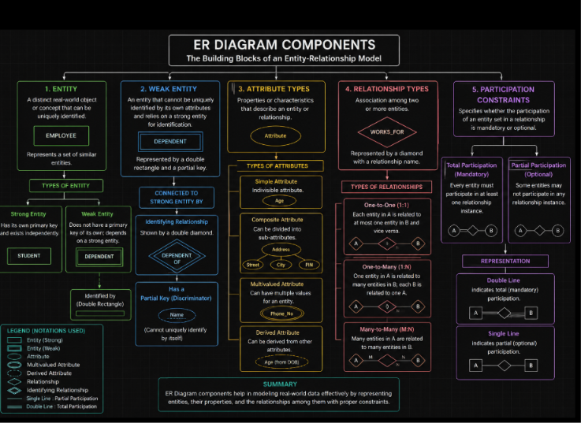

Design a Concept Map for ER Diagram Components: Entity, Weak Entity, Attribute Types, Relationship Types, and Participation Constraints (10 Marks)
1. Introduction
An Entity-Relationship (ER) Diagram is a graphical representation used in Database Management Systems (DBMS) to model the structure of a database. It illustrates entities, their attributes, relationships, and constraints, helping designers create an efficient database schema.

2. Entity
An Entity is a real-world object, person, place, or event about which data is stored.
Types of Entity
- Strong Entity
  - Has its own primary key.
  - Exists independently.
  - Represented by a single rectangle.
  - Example: Student, Employee.
- Weak Entity
  - Cannot exist without a strong entity.
  - Does not have a complete primary key.
  - Depends on a strong entity for identification.
  - Represented by a double rectangle.
  - Example: Dependent of an Employee.

3. Attribute Types
An Attribute describes the properties of an entity.
Types of Attributes
a) Simple Attribute
- Cannot be divided further.
- Example: Age
b) Composite Attribute
- Can be divided into sub-attributes.
- Example:
  - Address
    - Street
    - City
    - PIN Code
c) Multivalued Attribute
- Can have multiple values.
- Example:
  - Phone Number
  - Skills
d) Derived Attribute
- Obtained from another attribute.
- Example:
  - Age derived from Date of Birth.
e) Key Attribute
- Uniquely identifies an entity.
- Example:
  - Student_ID

4. Relationship Types
A Relationship represents the association between two or more entities.
Types of Relationships
One-to-One (1:1)
- One entity is related to only one entity.
- Example:
  - Person ↔ Passport
One-to-Many (1:M)
- One entity is associated with many entities.
- Example:
  - Department → Employees
Many-to-Many (M:N)
- Many entities are related to many entities.
- Example:
  - Student ↔ Course

5. Participation Constraints
Participation constraints specify whether an entity must participate in a relationship.
Total Participation (Mandatory)
- Every entity must participate.
- Represented by double lines.
Example:
Every employee must belong to a department.

Partial Participation (Optional)
- Participation is optional.
- Represented by single lines.
Example:
A customer may or may not place an order.

6. Symbols Used in ER Diagram
Symbol | Meaning
Rectangle | Strong Entity
Double Rectangle | Weak Entity
Oval | Attribute
Double Oval | Multivalued Attribute
Dashed Oval | Derived Attribute
Diamond | Relationship
Double Diamond | Identifying Relationship
Single Line | Partial Participation
Double Line | Total Participation

7. Advantages of ER Diagrams
- Simplifies database design.
- Clearly represents entities and relationships.
- Reduces data redundancy.
- Improves communication between developers and users.
- Serves as a blueprint for database implementation.

Conclusion
ER diagrams provide a clear visual representation of database structures by defining entities, attributes, relationships, and participation constraints. They help design accurate, efficient, and scalable databases, making them an essential tool in DBMS development.
This structure is suitable for a 10-mark university answer, with clear headings and enough detail to score well.

5. Construct a Concept Map Comparing Hierarchical, Network, and Relational Data Models with Their Key Properties.
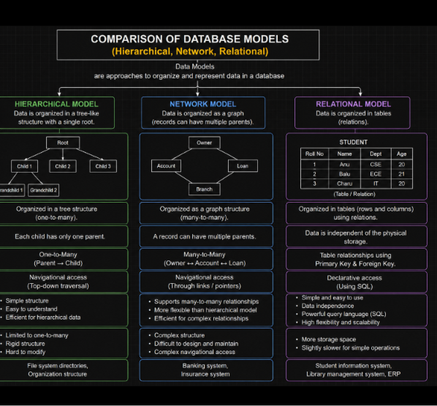
Diagram 5.1

Introduction
A Data Model is a collection of concepts used to describe how data is organized, stored, and managed in a database. Different data models have been developed to meet different application requirements. The three important database models are Hierarchical Model, Network Model, and Relational Model. Each model differs in its structure, relationships, advantages, and limitations.

1. Hierarchical Data Model
The Hierarchical Model organizes data in a tree-like structure. It follows a parent-child relationship, where each child has only one parent.
Key Properties
- Tree structure.
- One-to-Many (1:M) relationship.
- Each child has only one parent.
- Fast data access.
- Simple to understand.
Advantages
- Easy to implement.
- High performance for hierarchical data.
- Efficient for one-to-many relationships.
Disadvantages
- Does not support many-to-many relationships.
- Difficult to modify.
- Data redundancy may occur.
Example
A company database where one manager supervises many employees.

2. Network Data Model
The Network Model organizes data as a graph structure. It allows a record to have multiple parent records.
Key Properties
- Graph structure.
- Supports Many-to-Many (M:N) relationships.
- Multiple parent-child relationships.
- More flexible than the hierarchical model.
Advantages
- Efficient data access.
- Reduces redundancy.
- Supports complex relationships.
Disadvantages
- Complex structure.
- Difficult to design and maintain.
- Requires more programming effort.
Example
A student can enroll in multiple courses, and each course can have many students.

3. Relational Data Model
The Relational Model stores data in the form of tables (relations) consisting of rows and columns.
Key Properties
- Data stored in tables.
- Uses Primary Keys and Foreign Keys.
- Supports SQL for querying.
- Easy to understand and maintain.
- Most widely used model.
Advantages
- Simple structure.
- High data integrity.
- Reduced redundancy.
- Easy data retrieval using SQL.
- Supports normalization.
Disadvantages
- Performance may decrease with very large databases.
- Complex joins may increase execution time.
Example
Student Table
Student_ID | Name | Department
101 | Rahul | CSE
102 Priya AI

Comparison of Data Models
Feature | Hierarchical Model | Network Model | Relational Model
Structure | Tree | Graph | Tables
Relationship | One-to-Many | Many-to-Many | Keys (Primary & Foreign)
Parent Records | One Parent | Multiple Parents | No Parent-Child Structure
Data Access | Fast | Efficient | SQL Queries
Flexibility | Low | High | Very High
Complexity | Simple | Complex | Moderate
Redundancy | High | Less | Very Low
Ease of Use | Easy | Difficult | Easy
Most Suitable Organizational  For Hierarchies |  | Complex Modern Database Networks Applications

Relationship Among the Three Models
- The Hierarchical Model was the earliest data model and is suitable for treestructured data.
- The Network Model improved the hierarchical model by supporting many-tomany relationships.
- The Relational Model further simplified database management by organizing data into tables and using SQL for data retrieval.
- Today, the Relational Model is the most widely used because of its simplicity, flexibility, and support for data integrity.

Real-Time Example
Hierarchical Model
Company Organization
- CEO
- Manager
- Employees
One manager supervises many employees.
Network Model
University Database
- Student ↔ Course
A student can enroll in many courses, and each course can have many students.
Relational Model Bank Database Tables:
- Customer
- Account
- Transaction
These tables are connected using Primary Keys and Foreign Keys.

Advantages of Comparing Data Models
- Helps select the appropriate model for an application.
- Improves database design.
- Ensures efficient data organization.
- Supports better performance and scalability.
- Simplifies maintenance and data retrieval.

Summary Table
Data Model | Structure | Main Relationship | Example
Hierarchical Model | Tree | One-to-Many | Company Hierarchy
Network Model | Graph | Many-to-Many | Student–Course
Relational Model Tables Primary & Foreign Keys Banking System

Conclusion
The Hierarchical, Network, and Relational Data Models are important methods of organizing data in a database. The Hierarchical Model uses a tree structure suitable for one-to-many relationships, the Network Model uses a graph structure to support manyto-many relationships, and the Relational Model organizes data into tables connected by keys. Among these, the Relational Model is the most popular because it provides flexibility, data integrity, easy maintenance, and powerful SQL support. Understanding these models helps in selecting the most appropriate database design for different realworld applications.

